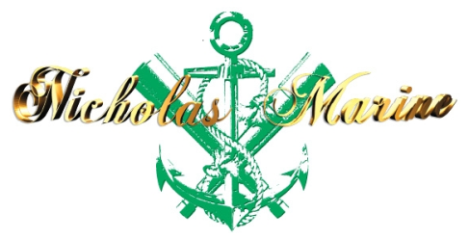 | 73000, Ukraine, Kherson,  14, Zalaegerseg Str.,  Tel: 097-366-45-78, 099-541-74-95, 0552-51-84-90  E-mail: nicholas-2010@mail.ru,  Skype: nicholas-2010 | Photo
APPLICATION FORM
A. SEAMAN’S PERSONAL DETAILS
POSITION TO APPLY FOR |  |  |  |  |  |  |  |  |  | CERTIFIED FOR
NAME / SURNAME
FATHER'S NAME |  |  |  |  |  |  |  |  |  | MOTHER'S NAME
D.O.B./P.O.B. |  |  |  |  |  |  |  |  |  | NATIONALITY
ADDRESS
MOB: |  |  |  |  |  | PHONE NO.: |  |  |  |  |  |  | E-mail
MARITAL STATUS |  |  |  |  |  |  |  |  | CHILDREN UNDER 18 YEARS
NEXT OF KIN |  |  |  |  |  |  |  |  | RELATION
NEXT OF KIN ADDRESS AND PHONE
GRADUATED FROM |  |  |  |  |  |  |  |  |  |  |  |  |  |  |  | USA VISA:
DEGREE OF DIPLOMA ISSUED
WEIGHT |  |  | HEIGHT |  |  |  |  |  |  |  | EYES COLOR |  |  |  | HAIR COLOR

B. DOCUMENTATION
CERTIFICATES |  |  | NUMBER | 1SSUING DATE |  | VAL1DATION DATE |  | ISSUING PLACE
SEAMAN’S BOOK
INTERNATIONAL PASSPORT
CERTIFICATE OF COMPETENCY
ENDORSEMENT OF CERTIFICATE
GMDSS GENERAL OPERATOR’S CERTIFICATE
GMDSS ENDORSEMENT
RADAR OBSERVATION (A-1/12, A-II/1, A-II/2, B-I/12)
ARPA (A-I/12, A-II/1,A-II/2, B-I/12)
SHIP SECURITY OFFICER (ISPS Code)
SHIP SAFETY OFFICER (ISM Code)
BASIC SAFETY TRAINING (A-VI/1)
PROF.IN SURVIVAL CRAFT (A-VI/2)
FIRST MEDICAL AID (A-VI-4)
MEDICAL CARE ON BOARD SHIP (A-VI/4 p. 4-6)
ADVANCED FIRE FIGHTING (A-VI/3)
HAZARDOUS CARGOES (B-V/4, B-V/5)
SHIP HANDLING ARRANGEMENTS (A-II/2)
RO-RO PASSANGER SHIPS
TANKER FAMILIARIZATION
LAST MEDICAL
DRUG ALCOHOL TEST

YELLOW FEVER VACCINATION CARD
Another States  Seaman's books | Rank | Document No |  |  | Issued |  | Valid
Another States Certificates of competency | Rank | Document No |  |  | Issued |  | Valid

 | C. PREVIOUS SEA SERVICE
VESSEL |  | FLAG | TYPE / DWT | ENG / HP | RANK | S/ON | S/OFF | OWNERS

PLEASE COMPLETE CONTACT DETAILS OF YOUR PREVIOUS EMPLOYERS FOR REFERENCES

COMPANY | ADDRESS | TEL NUMBERS

English abilities: Good: ⁯ Average: ⁯ Poor: ⁯

ACCEPTABLE SALARY:

SIGNATURE: DATE:

